AI-Driven Communication Networks for Smart Cities

Dr. R. Sharma¹, Dr. P. Singh², and Ms. K. Kaur³
¹ Department of Electronics, ABC University, New Delhi, India
² Department of Computer Science, XYZ Institute, Ludhiana, India
³ School of Electrical Engineering, LMN College, Amritsar, India
E-mail: mirma@abcuniv.ac.in¹, psingh@abc.ac.in², psingh@34Gmail.com³

ABSTRACT
An abstract of up to 250 words should concisely summarize the purpose, methodology, key results, and conclusions of the work. This paper presents an AI-enabled communication framework for smart city networks, integrating adaptive routing and data optimization through machine learning. Simulation results in MATLAB show a 22% improvement in energy efficiency and 15% reduction in packet loss compared with conventional protocols.
Keywords: Artificial Intelligence, Communication Networks, IoT, Machine Learning, Smart Cities (Five Keywords)

INTRODUCTION
The document should be prepared on A4 size paper in a single-column layout, using Times New Roman font (size 11) with 1.15 line spacing (Mitchell et al, 2017, p, 189). Reference and Citation style is Harvard Referencing Basics.
The rapid growth of smart cities demands efficient data exchange between heterogeneous devices. Existing communication systems face challenges in scalability and energy efficiency. This work introduces an AI-based model that predicts network load and dynamically allocates bandwidth. The rest of the paper is structured as follows: Section 2 reviews related work, Section 3 presents the methodology, Section 4 discusses results, and Section 5 concludes.
LITERATURE REVIEW
Prior research on intelligent communication networks has primarily focused on energy-aware routing and cloud-based data fusion. However, limited work exists on on-device learning and adaptive network control for IoT applications. This study bridges that gap through a hybrid AI-IoT communication model (Mitchell et al, 2017, p, 189).
METHODOLOGY / SIMULATION SETUP
Simulations were conducted using NS-3 and MATLAB environments. The dataset included network traffic patterns collected from 500 IoT nodes. A supervised learning algorithm predicted congestion points based on packet delay variance (Mitchell, 2017, p. 189). The following key parameters were used:
• Transmission power: 15 dBm
• Channel bandwidth: 2 MHz
• Simulation time: 600 s
• Learning model: Random Forest (100 trees)
RESULTS AND DISCUSSION
The proposed system achieved an average throughput of 2.3 Mbps compared to 1.9 Mbps in standard routing.
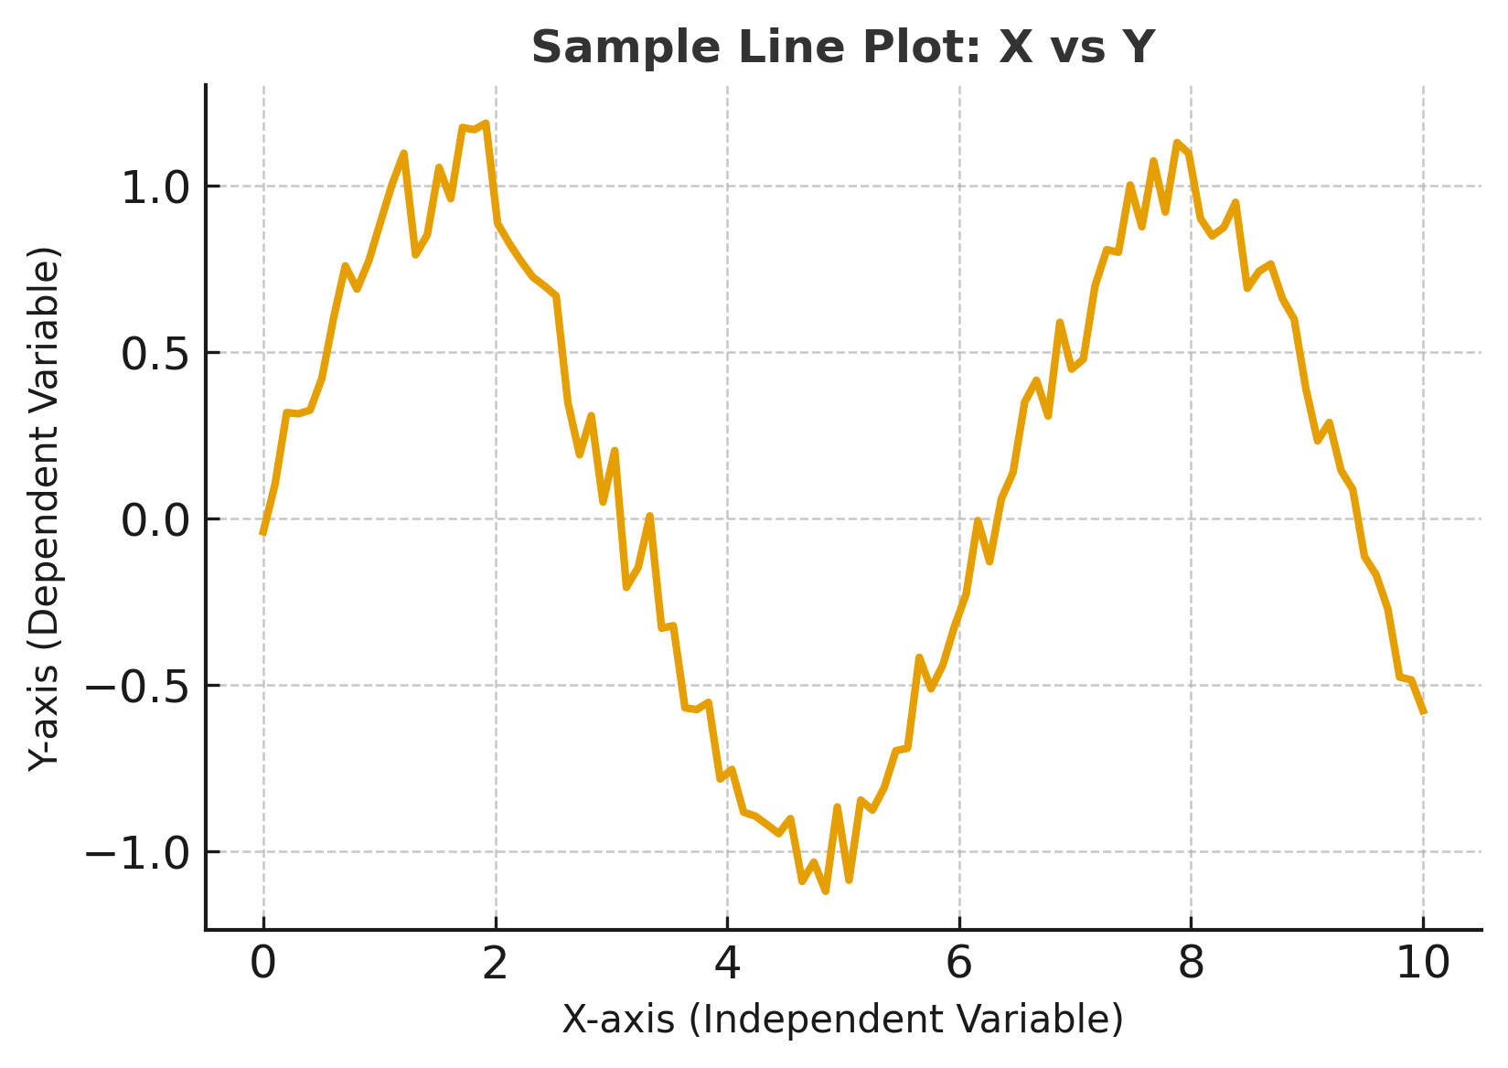
Figure 1 Figure caption
Figure 1 shows throughput comparisons under variable load conditions. Table 1 summarizes the quantitative results.
Metric | Conventional | Proposed
Throughput (Mbps) | 1.9 | 2.3
Packet Loss (%) | 8.2 | 6.1
Latency (ms) | 130 | 105
Table 1: Performance comparison between conventional and proposed models
CONCLUSION
The AI-based communication framework improved performance and adaptability in smart city environments. Future work will focus on integrating reinforcement learning for real-time optimization and expanding the dataset to urban testbeds. Citation Style (Mitchell et al, 2017, p, 189)
ACKNOWLEDGEMENTS
The authors acknowledge support from the Department of Physics, XYZ University, under the AI Communication Systems Initiative. Reference and Citation style is Harvard Referencing Basics.
BIBLIOGRAPHY/REFERENCES
Mitchell, J.A. and Thomson, M. (2017) A guide to citation. 3rd edn. London: London Publishings.
Mitchell, J.A. ‘How citation changed the research world’, The Mendeley, 62(9), p70-81.
Mohammad Arif Kamal, S. G. (2020). Exploration of Arabesque as an Element of Decoration in Islamic heritage Buildings: The Case of Indian and Persian Architecture. Journal of Xi’an University of Architecture & Technology, 843-852.
Mitchell, J.A. and Thomson, M. (2017). A guide to citation. 3rd edn. London: London Publishings.
Zhang, L. et al. (2021). Machine learning-based IoT network optimization. IEEE Transactions on Industrial Informatics, 17(6), pp.4040–4050.
Khan, R. and Singh, P. (2023). AI for sustainable communication networks. Journal of Smart Systems, 12(4), pp.210–218.

